Question1:
b) The pseudo code for the program is shown below, and the actual implementation of the program is in lab7Q1Q3.py as Question1(array, array).

The graph generate by the code is shown below:
Graph generated with Initial condition 1
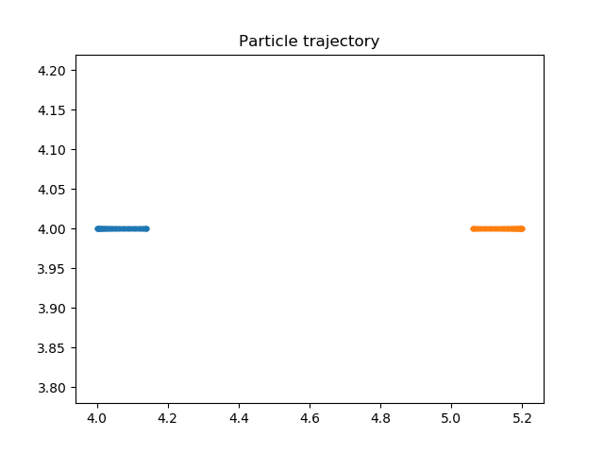
Note: The particle quickly speeds up and slows down when they are approximately 1 unit from each other. Therefore, graph shows two straight line closing on each other.
Graph generated with Initial condition 2
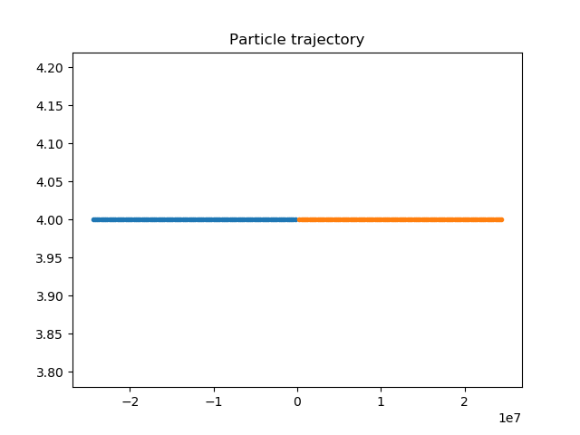
Note: For this graph, since the initial position of the particles are so close, they are catapulted away from each other. That is why the x-axis have such a huge value.

Graph generated with Initial condition 3
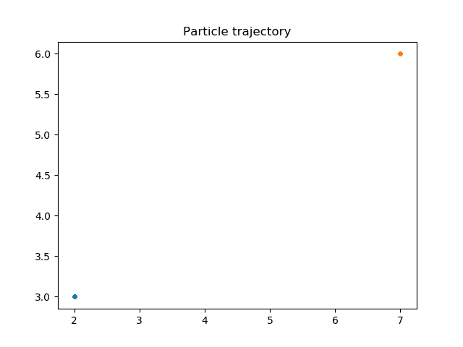
Note: Although in this graph, the particles seem stationery, but they are indeed moving, just very slow. If the program simulates with t from 0 to 10,000 it will show the movement of the two particles.
c) The first and third initial condition will lead to an oscillatory motion of the two particles. Since the energy is conserved in this equation, the repulsive force for the second equation will generate more energy than the energy produces by two particles approach each other from infinite distance. Therefore, the second initial condition will not produce an oscillatory motion.

Question3:
a) The implementation of the code is in lab7Q1Q3.py.
c) The graph for Concentration of chemicals is shown below.
